# Swedfund’s Policy for Sustainable Development

1. **Purpose and scope of this Policy**

Swedfund’s goal and mission as the Swedish Development Finance Institution is to fight poverty by investing in sustainable businesses in emerging markets and thereby contributing to the implementation of Agenda 2030. Swedfund’s business model is based on three equally important pillars: Impact on Society, Sustainability and Financial Viability. This Policy for Sustainable Development describes what Swedfund expects from itself and its investments in order to fulfil our ambitions with the first and second pillars – Impact on Society and Sustainability.

Our investments are long-term commitments and it is our conviction that sustainable business practices and embedding of sustainability in decision making and strategies mitigate risks and create value in our portfolio companies and in society as a whole. By “sustainability” we mean environmental and social considerations, human rights, corporate governance and business ethics.

This Policy for Sustainable Development forms an integral part of Swedfund’s Sustainability Framework[1] and applies to all Swedfund investments, Swedpartnership financial support[2] and Swedfund’s own activities.

1. **Principles**

Agenda 2030, which includes the UN Sustainable Development Goals and Addis Ababa Action Agenda as well as the Paris Agreement, constitutes a transformative plan of action. Combined with the United Nations Guiding Principles on Business and Human Rights, this global agenda aims to eliminate poverty, reduce inequalities and protect our planet and guides Swedfund’s sustainability efforts.

Swedfund is a signatory or has committed to a number of international standards, principles for responsible investment and sustainable business practices. These standards and commitments have been integrated into our business model and investment process. A complete list of our external commitments is included in our Ethical Compass.iii

1. **Swedfund’s commitment to our stakeholders**

The corner stones of our *responsible investment process* are the following:

* We will not finance any activity, production, use, distribution, business or trade involving any activity excluded by the EDFI Harmonised Exclusion List.iv
* Based on the requirements in this Policy, we will make an environmental, social and governance assessment in all our prospective investments and when exiting our investments.
* We will only invest in businesses that share our view on sustainability. Not all business investments will meet our sustainability requirements from the start. We will then require a commitment to an action plan that aims to ensure compliance within a defined timeline.
* We monitor the performance of our portfolio companies and support them whenever applicable.

Swedfund recognizes that all business enterprises should respect *human rights*. This means avoiding infringing human rights and addressing adverse human rights impacts of the enterprise:

* This responsibility to respect human rights refers to all internationally recognized human rights - understood, at a minimum, to be the Universal Declaration of Human Rights, the International Covenant on Civil and Political Rights and the International Covenant on Economic, Social and Cultural Rights (collectively known as the International Bill of Human Rights) and the ILO’s Declaration on Fundamental Principles and Rights at Work.
* We commit toact consistently with the United Nations Guiding Principles on Business and Human Rights (UNGP), gradually developing and implementing a human rights due diligence process - which is largely embedded in our existing environmental and social management system - to identify, prevent, mitigate and account for how we address our impacts on human rights and how we engage and consult with potentially affected stakeholders.
* To fulfill our commitment to respect human rights, we aim to avoid causing or contributing to adverse human rights impacts resulting from our own activities and to address such impacts if they occur. Where we identify that we have caused or contributed to adverse human right impacts, we will provide for, or cooperate in, their remediation through legitimate processes.
* We also aim to prevent or mitigate adverse human rights impacts that are directly linked to our operations by our business relationships. Where we identify human right impacts that are directly linked to our operations through our business relationships, we will seek to work with our business partners to ensure that remediation occurs.

In addition, we promote *gender equality*, which is central part of poverty reduction and our mission. We aim to ensure that women, men, girls and boys have equal rights, equal conditions, equal opportunities and equal power.

Further, we are committed to protect the *environment and climate:*

* We aim to contribute to the fulfillment of the goals of the Paris Agreement.
* We seek to minimise the possible negative impacts caused by our operations and investments.
* Within the area of energy, we have chosen to focus primarily on renewable energy production and distribution.

Swedfund values and supports *ethical business practices and good corporate governance* in the following ways:

* We only invest in sound and clear corporate structures that do not contribute to tax avoidance, corruption or bribery, money laundering, terrorist financing or any other fraudulent or corrupt practices.
* We refrain from taking part in investments through intermediary jurisdictions which have been assessed within the framework of the OECD Global Forum Peer Review Process and either have not been approved in Phase 1 or been deemed Non-Compliant or only Partially Compliant in Phase 2.
* We provide a whistleblowing service in order to make it easy to anonymously report serious irregularities within Swedfund and its portfolio companies.
* We strive to increase the transparency of our operations and investments within the boundaries of our confidentiality requirements and we provide information regarding our activities on our website and through other channels including our annual integrated report.

1. **Sustainability requirements for Swedfund’s investments**

When investing, we expect each investment to commit to the following requirements, in addition to the requirements stipulated in other key documents in Swedfund’s Sustainability Framework.

When investing with other Development Finance Institutions, the EDFI Harmonised Environmental and Social Standards shall be applied as minimum standards. When investing with other investors that have a mind-set similar to ours with respect to sustainability issues, Swedfund may agree to apply requirements which differ from, but are substantially similar to, the requirements in this Policy in order to harmonize the requirements of all investors, provided that such requirements are satisfactory to Swedfund.

**Sustainability Requirements for direct investments, financial institutions and funds**

* Comply with legal and regulatory requirements in the jurisdictions where they operate;
* Comply with the Harmonised EDFI Exclusion List;iv
* Adhere to or act consistently with the ILO’s Declaration on Fundamental Principles and Rights at Work and the ILO’s Basic Terms and Conditions of Employment;v
* Adhere to applicable IFC Performance Standards and IFC EHS Guidelinesappropriate to the size and nature of the business;
* Respect all internationally recognised human rights and conduct regular human rights due diligence in order to identify, prevent, mitigate account for potential adverse risks/impacts;
* Strive to ensure that the ratio of men to women (in management positions) shall develop positively/approach an equilibrium over a five-year period with the base year corresponding to the investment year;
* Assess and support reduction of climate emissions;
* Provide information on environmental, social and corporate governance issues (including human rights) and on development impact, as requested by Swedfund; and
* Facilitate Swedfund’s environmental and/or social monitoring visits and/or audits including performing human rights due diligence and human rights impact assessments.

As regards financial institutions and funds, we require, in addition to the above-mentioned Sustainability Requirements, that the financial institution and fund manager develop a robust environmental and social management system/responsible investment code including the requirements above, as applicable, for their borrowers and investments.

**Additional requirements or recommendations in specific situations for direct investments, financial institutions and funds**

In specific situations, such as in the case of high ESG risks and impacts or where the investment already fulfils the fundamental sustainability requirements, it might be necessary to apply additional requirements and recommendations. In these cases, we engage with the investment to identify relevant areas and applicable guidelines for further development. Some examples of the requirements/recommendations in specific situations include:

* Adopting the ten principles of UN Global Compact;
* Complying with UN Principles for Responsible Investment;
* Acting consistently with the United Nations Guiding Principles on Business and Human Rights (UNGP) appropriate to the size and nature of the business~~;~~
* Complying with relevant client protection principles;
* Adopting additional international guidelines to manage the main risks and impacts of the company, such as guidelines on water and land;
* Striving for the total remuneration to senior executives to be reasonable and well-considered;
* Embedding sustainability in the agenda of board of directors by including sustainability competence in the board, establishing a sustainability committee, or including sustainability as a standard item for board meetings;
* Providing transparent sustainability reporting for all stakeholders; and
* Adopting and implement a whistleblowing service to make it easy to anonymously report serious irregularities.

1. **Complaints mechanism**

**S**wedfund requires each portfolio company to provide an appropriate grievance mechanism that is available to potentially affected stakeholders.

Nonetheless, Swedfund recognises that individuals and communities that are subject to risks or impacts from Swedfund or our portfolio companies also need to be able to lodge a grievance directly with Swedfund. Therefore, Swedfund’s makes a grievance mechanism available on Swedfund’s website, to respond in a timely manner to legitimate concerns and grievances about Swedfund and Swedfund’s portfolio companies.

In addition, via Swedfund’s website, Swedfund makes a whistleblowing service available for employees, contractors, interns, etc., at our portfolio companies to make it easy to anonymously report serious irregularities.

1. **Approval, revision and distribution**

This Policy for Sustainable Development was adopted by the Board of Swedfund International AB on February xx 2019. The Policy is distributed to all employees and portfolio companies of Swedfund. The Policy is publicly available on the webpage and to all Swedfund stakeholders.

We regularly evaluate the results of implementing this policy. The policy will be revised annually and updated when necessary.

1. **Swedfund’s Sustainability Framework**

   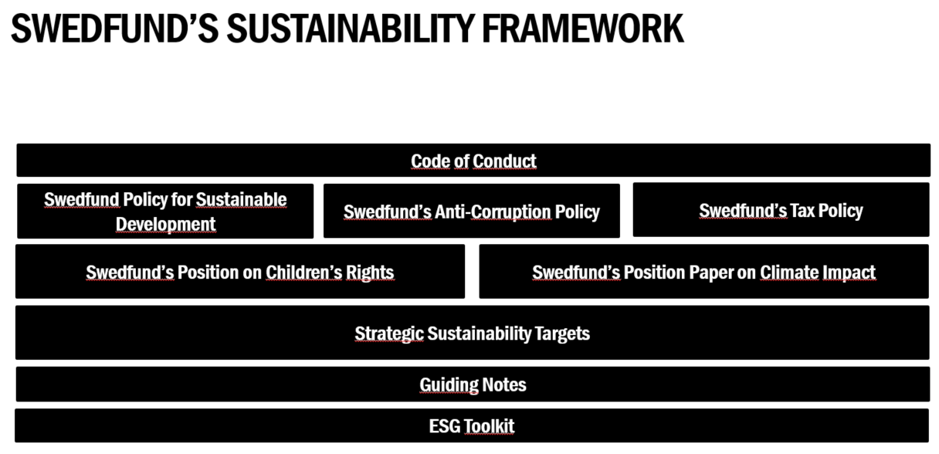
2. **Swedpartnership’s** financial support is a conditional loan for projects based on transfers of know-how and investments in machinery and equipment over a timeframe of up to 18 months.

   iii **Our Ethical Compass**: Link to be inserted

   iv **EDFI Exclusion List**: https://www.swedfund.se/media/1122/harmonized_edfi_exclusion_list_2012.pdf

   v **The ILO’s Declaration on Fundamental Principles and Rights at Work** refers to The Freedom of Association and Protection of the Right to Organise Convention, 1948 (No. 87); Right to Organise and Collective Bargaining Convention, 1949 (No. 98); the Forced Labour Convention, 1930 (No. 29); Abolition of Forced Labour Convention, 1957 (No. 105); Minimum Age Convention, 1973 (No. 138); Worst Forms of Child Labour Convention, 1999 (No. 182); the Equal Remuneration Convention, 1951 (No. 100); and the Discrimination (Employment and Occupation) Convention, 1958 (No. 111). **ILO Basic Terms and Conditions of Employment** refers to Hours of Work (No. 1); Minimum Wage (No. 26, 131); and Occupational Safety and Health (No. 155).  